**DAILY ONLINE ACTIVITIES SUMMARY**

|  |  |  |  |  |  |  |  |  |
| --- | --- | --- | --- | --- | --- | --- | --- | --- |
| **Date:** | **29/05/202** | | | | | **Name:** | **Anjali Manohar Prabhu** | |
| **Sem & Sec** | **4th Sem Section - ‘A’** | | | | | **USN:** | **4AL18CS007** | |
| **Online Test Summary** | | | | | | | | |
| **Subject** | | **Operating System** | | | | | | |
| **Max. Marks** | | **30** | | **Score** | | | **29** | |
| **Certification Course Summary** | | | | | | | | |
| **Course** | **Maths in Data Science** | | | | | | | |
| **Certificate Provider** | | | 1. **Great Learning Academy** | | **Duration** | | | **2.5hrs** |
| **Coding Challenges** | | | | | | | | |
| **Problem Statement: 1. Write a Java program to find the size of the largest ‘+’ formed by all ones in a binary matrix**  **Problem Statement : 2. Write a C program to generate first N Armstrong Number** | | | | | | | | |
| **Status: Completed** | | | | | | | | |
| **Uploaded the report in Github** | | | | | **YES** | | | |
| **If yes Repository name** | | | | | [**https://github.com/vinisharen/lockdown-coding**](https://github.com/vinisharen/lockdown-coding) | | | |
| **Uploaded the report in slack** | | | | | **NO** | | | |

Online Test Details: OS online test was conducted on date 29/05/2020 from 9:15 am to 10:00 am There were 30 question in total where each question consist of 1 mark, and the score I got is 29/30

SNAPSHOT: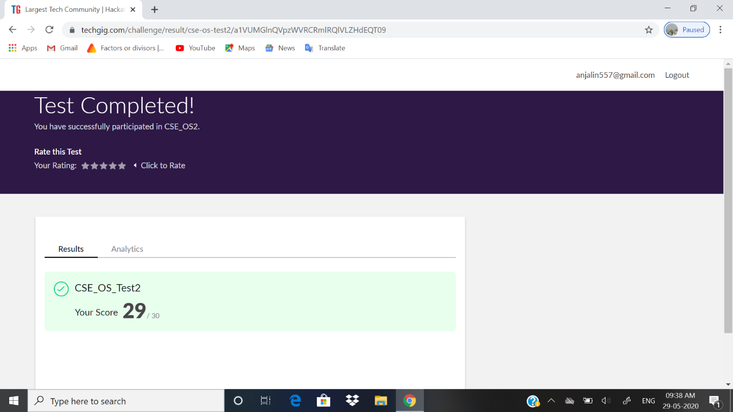

Certification Course Details: For a lot of higher level courses in Machine Learning and Data Science, you find you need to freshen up on the basics in mathematics - stuff you may have studied before in school or university, but which was taught in another context, or not very intuitively, such that you struggle to relate it to how it’s used in Computer Science. This specialization aims to bridge that gap, getting you up to speed in the underlying mathematics, building an intuitive understanding, and relating it to Machine Learning and Data Science.

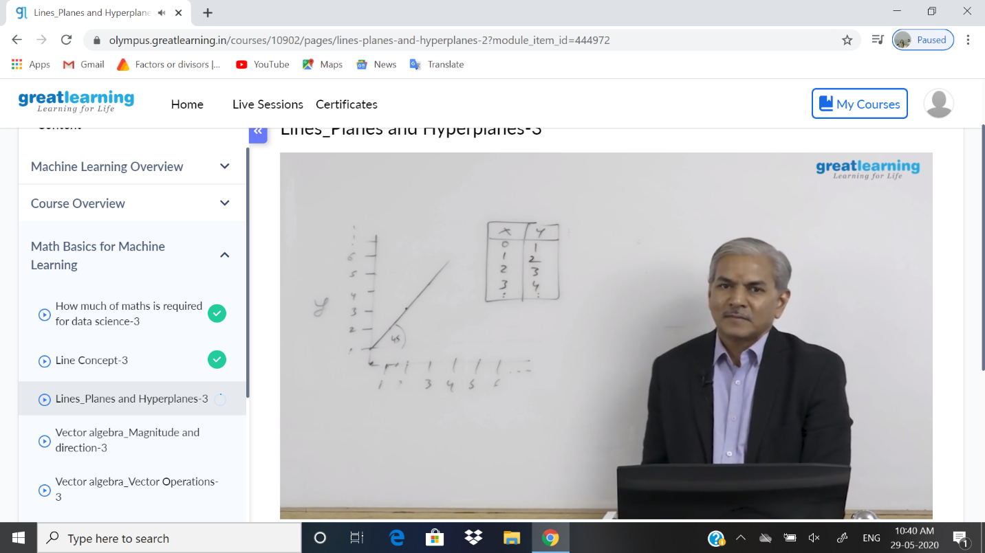

ONLINE CODING DETAILS:

PROBLEM 1: **Write a Java program to find the size of the largest ‘+’ formed by all ones in a binary matrix**

SNAPSHOT: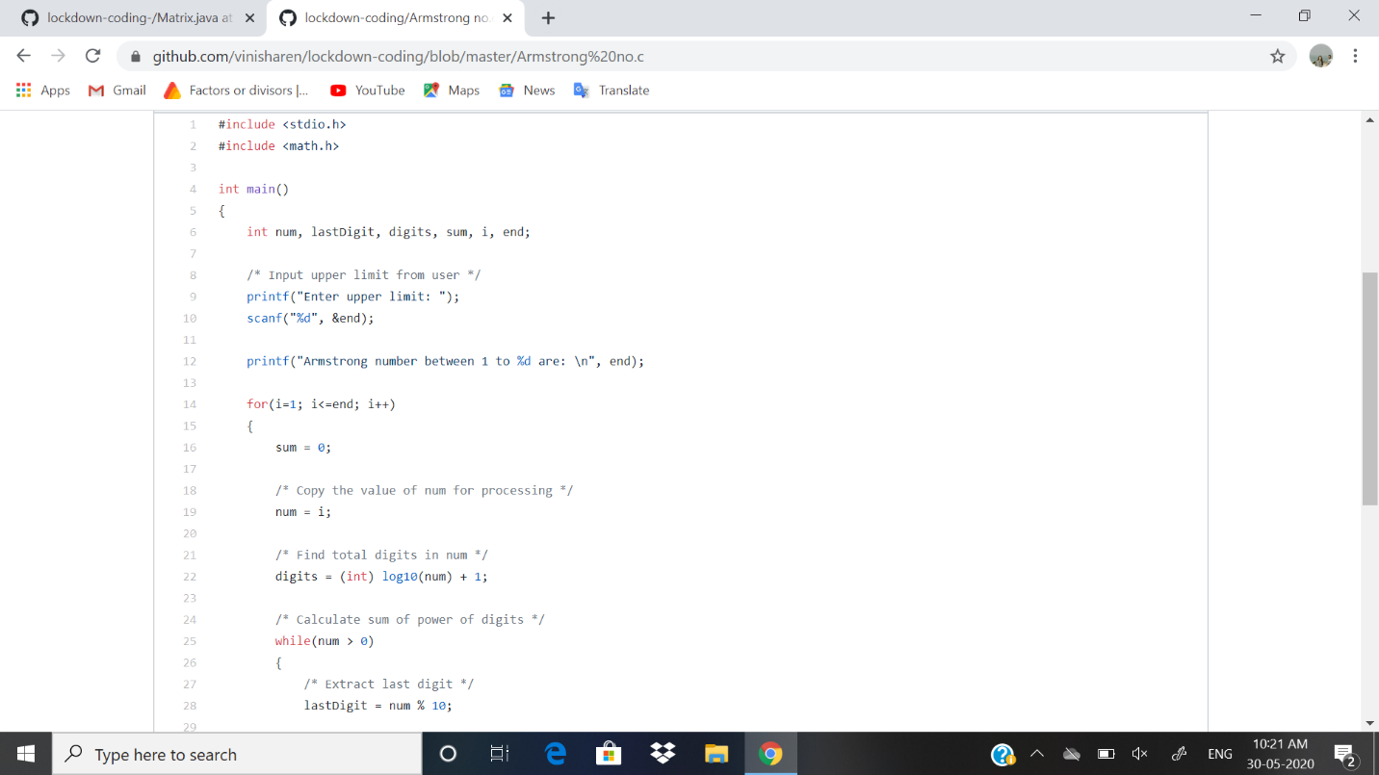

Problem 2: **Write a C program to generate first N Armstrong Number.**

**Snapshot:**